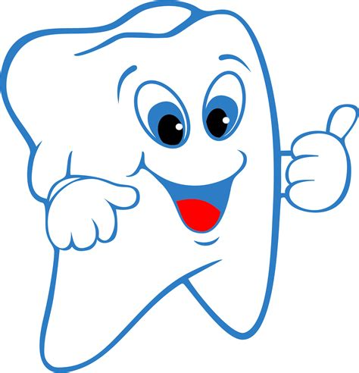Children’s Dental Health Poster Contest & Fair!!

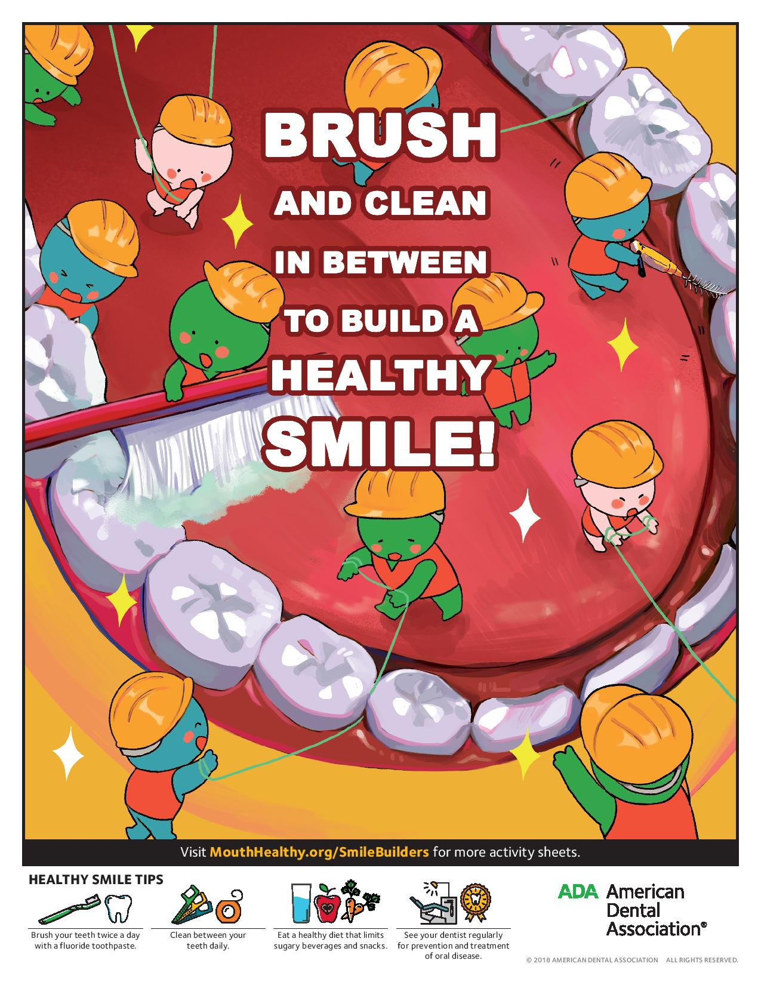

**Event to Include:**

* **Multiple Prize Winners**
* **Games and Entertainment**
* **Dental Q&A**
* **Information Booths**
* **Fun for the Entire Family**

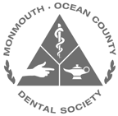

**PRIZE OF $800.00 AWARDED TO WINNER**

**PLUS A SPECIAL SEPARATE PRIZE AWARDED TO THE BEST SCDC PATIENT POSTER**

**Hosted by the Monmouth-Ocean County Dental Society of the ADA**

**Magician Performance from 1:45 pm to 2:30 pm**

**Date: Sunday, February 10th**

**Time: 1:00 pm to 3:00 pm**

**Location: Monmouth Mall**

**Atrium next to Macy’s**

**Deadline for poster submission is Friday February 1st!!!**

